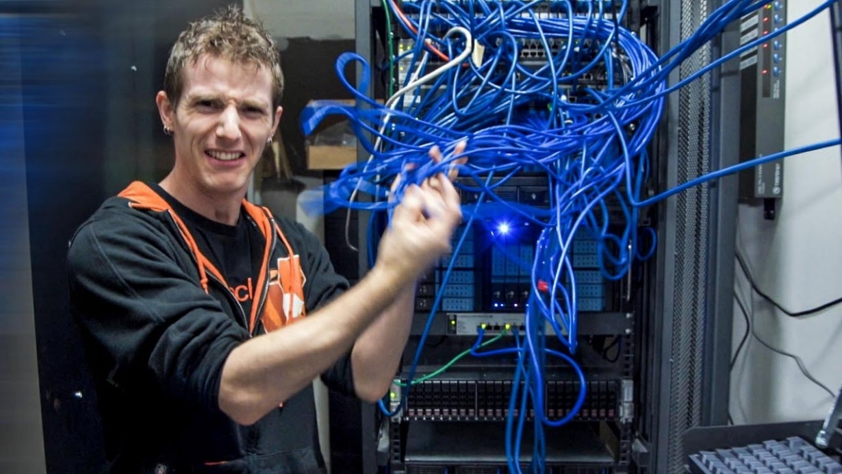

**Single Area OSPF v2 and v3**

Brendon Ahn | Advanced Cisco | 9/2/2022-9/16/2022



**Purpose**

To set up Single Area OSPF v2 and v3 on a 5 router network.

**Background**

OSPF(Open Shortest Path First) originally came from the 80s and v2 and v3 came later, 1998 and 2008 respectively. OSPF was created by the Internet Engineering Task Force to handle large IP networks and put them into areas(smaller networks). With networks becoming bigger and bigger it is important that routers are able to work efficiently and scalability has become increasingly important to have. OSPF is both efficient and scalable.

OSPF is a routing method that scales up easily due to the sharing of link-state databases which means a router shares topologies with its neighbors. It can split up groups of routers into areas. Since we were dealing with a smaller simpler network single area ospf was a good protocol to use. OSPF finds the shortest path to a destination which makes it efficient as well, hence its name. The way OSPF computes the shortest path is using a Dijkstsra’s algorithim based routing method, assigning costs and using the “cheapest” route available. It also guartantees loop free paths.

OSPF works for both IPv4 and IPv6 and can be used on most routers. These aspects are very important because it not only accounts for IPv4(old ips) but the “newer” IPv6 addresses that are set to come into place as we run out of IPv4 addresses. Being able to implement OSPFv3 on top of OSPFv2 is critical for new/expanding enterprises.

In all OSPF is a very efficient and useful protocol, that can be used within many companies and should be used. Learning OSPF would be a great boon in finding success in a field that requires routing knowledge,

**Lab Summary**

We designed and subnetted IPv4 and IPv6 networks for single area OSPF v2 and v3 across 5 routers. We had to get pings to work across all routers and two pcs.

**Topology**

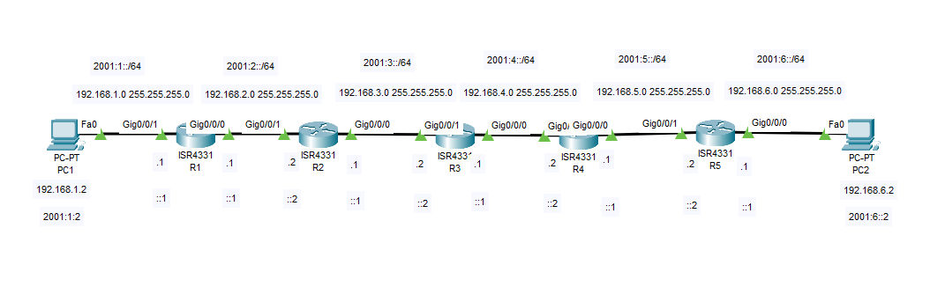

**Lab Commands**

OSPFv2 Configuration

* Router (config)#router ospf 1

1 is the process-id and this command starts OSPF for IPv4

* Router (config-router)#router-id 1.1.1.1

1.1.1.1 is identification number for this router and it must be unique on every router

* Router (config-router)#network 192.168.1.0 0.0.0.255 area 1

192.168.1.0/24 is added to the OSPF routing table with this command. All directly connected networks that you want in the routing table should be added with the network command. All networks you want to relay should be on the same area for Single Area OSPF.

OSPFv3 Configuration

* Router (config)#ipv6 router ospf 1

1 is the process-id and this command starts OSPF for IPv6. Make sure you have done the IPv6 unicast-routing command otherwise this command won’t work.

* Router(config-rtr)#router-id 1.1.1.1

1.1.1.1 is identification number for this router and it must be unique on every router, but it does not have to be different between the IPv4 and IPv6

* Router(config-if)#ipv6 ospf 1 area 1

1 is the process-id and 1 is the area number. All networks you want to relay should be on the same area for Single Area OSPF. For this command you want the IPv6 Address of this interface and the connected interface to be on the same network

**Router Configuration**

R1 configuration

Current configuration : 1930 bytes

Last configuration change at 19:38:55 UTC Wed Sep 7 2022

version 16.7

!

service timestamps debug datetime msec

service timestamps log datetime msec

platform qfp utilization monitor load 80

no platform punt-keepalive disable-kernel-core

!

hostname R1

!

boot-start-marker

boot-end-marker

!

vrf definition Mgmt-intf

address-family ipv4

exit-address-family

address-family ipv6

exit-address-family

!

no aaa new-model

no ip domain lookup

subscriber templating

vtp domain cisco

vtp mode transparent

ipv6 unicast-routing

!

multilink bundle-name authenticated

license udi pid ISR4321/K9 sn FDO220523GF

no license smart enable

diagnostic bootup level minimal

spanning-tree extend system-id

redundancy

mode none

!

interface GigabitEthernet0/0/0

ip address 192.168.2.1 255.255.255.0

negotiation auto

ipv6 address 2001:2::1/64

ipv6 ospf 1 area 1

!

interface GigabitEthernet0/0/1

ip address 192.168.1.1 255.255.255.0

negotiation auto

ipv6 address 2001:1::1/64

ipv6 ospf 1 area 1

!

interface Serial0/1/0

no ip address

shutdown

!

interface Serial0/1/1

no ip address

shutdown

!

interface GigabitEthernet0/2/0

no ip address

shutdown

negotiation auto

!

interface GigabitEthernet0/2/1

no ip address

shutdown

negotiation auto

!

interface GigabitEthernet0

vrf forwarding Mgmt-intf

no ip address

shutdown

negotiation auto

!

router ospf 1

router-id 1.1.1.1

passive-interface GigabitEthernet0/0/1

network 192.168.1.0 0.0.0.255 area 1

network 192.168.2.0 0.0.0.255 area 1

!

ip forward-protocol nd

ip http server

ip http authentication local

ip http secure-server

ip tftp source-interface GigabitEthernet0

!

ipv6 router ospf 1

router-id 1.1.1.1

control-plane

!

line con 0

transport input none

stopbits 1

line aux 0

stopbits 1

line vty 0 4

login

!

wsma agent exec

wsma agent config

wsma agent filesys

wsma agent notify

!

End

R2 configuration

Current configuration : 1930 bytes

Last configuration change at 19:41:52 UTC Wed Sep 7 2022

version 16.7

!

service timestamps debug datetime msec

service timestamps log datetime msec

platform qfp utilization monitor load 80

no platform punt-keepalive disable-kernel-core

!

hostname R2

!

boot-start-marker

boot-end-marker

!

vrf definition Mgmt-intf

address-family ipv4

exit-address-family

address-family ipv6

exit-address-family

!

no aaa new-model

no ip domain lookup

subscriber templating

vtp domain cisco

vtp mode transparent

ipv6 unicast-routing

!

multilink bundle-name authenticated

license udi pid ISR4321/K9 sn FDO220523GF

no license smart enable

diagnostic bootup level minimal

spanning-tree extend system-id

redundancy

mode none

!

interface GigabitEthernet0/0/0

ip address 192.168.3.1 255.255.255.0

negotiation auto

ipv6 address 2001:3::1/64

ipv6 ospf 1 area 1

!

interface GigabitEthernet0/0/1

ip address 192.168.2.1 255.255.255.0

negotiation auto

ipv6 address 2001:2::1/64

ipv6 ospf 1 area 1

!

interface Serial0/1/0

no ip address

shutdown

!

interface Serial0/1/1

no ip address

shutdown

!

interface GigabitEthernet0/2/0

no ip address

shutdown

negotiation auto

!

interface GigabitEthernet0/2/1

no ip address

shutdown

negotiation auto

!

interface GigabitEthernet0

vrf forwarding Mgmt-intf

no ip address

shutdown

negotiation auto

!

router ospf 1

router-id 2.2.2.2

network 192.168.2.0 0.0.0.255 area 1

network 192.168.3.0 0.0.0.255 area 1

!

ip forward-protocol nd

ip http server

ip http authentication local

ip http secure-server

ip tftp source-interface GigabitEthernet0

!

ipv6 router ospf 1

router-id 2.2.2.2

control-plane

!

line con 0

transport input none

stopbits 1

line aux 0

stopbits 1

line vty 0 4

login

!

wsma agent exec

wsma agent config

wsma agent filesys

wsma agent notify

!

End

R3 configuration

Current configuration : 1930 bytes

Last configuration change at 19:44:22 UTC Wed Sep 7 2022

version 16.7

!

service timestamps debug datetime msec

service timestamps log datetime msec

platform qfp utilization monitor load 80

no platform punt-keepalive disable-kernel-core

!

hostname R3

!

boot-start-marker

boot-end-marker

!

vrf definition Mgmt-intf

address-family ipv4

exit-address-family

address-family ipv6

exit-address-family

!

no aaa new-model

no ip domain lookup

subscriber templating

vtp domain cisco

vtp mode transparent

ipv6 unicast-routing

!

multilink bundle-name authenticated

license udi pid ISR4321/K9 sn FDO220523GF

no license smart enable

diagnostic bootup level minimal

spanning-tree extend system-id

redundancy

mode none

!

interface GigabitEthernet0/0/0

ip address 192.168.4.1 255.255.255.0

negotiation auto

ipv6 address 2001:4::1/64

ipv6 ospf 1 area 1

!

interface GigabitEthernet0/0/1

ip address 192.168.3.1 255.255.255.0

negotiation auto

ipv6 address 2001:3::1/64

ipv6 ospf 1 area 1

!

interface Serial0/1/0

no ip address

shutdown

!

interface Serial0/1/1

no ip address

shutdown

!

interface GigabitEthernet0/2/0

no ip address

shutdown

negotiation auto

!

interface GigabitEthernet0/2/1

no ip address

shutdown

negotiation auto

!

interface GigabitEthernet0

vrf forwarding Mgmt-intf

no ip address

shutdown

negotiation auto

!

router ospf 1

router-id 3.3.3.3

network 192.168.3.0 0.0.0.255 area 1

network 192.168.4.0 0.0.0.255 area 1

!

ip forward-protocol nd

ip http server

ip http authentication local

ip http secure-server

ip tftp source-interface GigabitEthernet0

!

ipv6 router ospf 1

router-id 3.3.3.3

control-plane

!

line con 0

transport input none

stopbits 1

line aux 0

stopbits 1

line vty 0 4

login

!

wsma agent exec

wsma agent config

wsma agent filesys

wsma agent notify

!

End

R4 configuration

Current configuration : 1930 bytes

Last configuration change at 19:51:43 UTC Wed Sep 7 2022

version 16.7

!

service timestamps debug datetime msec

service timestamps log datetime msec

platform qfp utilization monitor load 80

no platform punt-keepalive disable-kernel-core

!

hostname R4

!

boot-start-marker

boot-end-marker

!

vrf definition Mgmt-intf

address-family ipv4

exit-address-family

address-family ipv6

exit-address-family

!

no aaa new-model

no ip domain lookup

subscriber templating

vtp domain cisco

vtp mode transparent

ipv6 unicast-routing

!

multilink bundle-name authenticated

license udi pid ISR4321/K9 sn FDO220523GF

no license smart enable

diagnostic bootup level minimal

spanning-tree extend system-id

redundancy

mode none

!

interface GigabitEthernet0/0/0

ip address 192.168.5.1 255.255.255.0

negotiation auto

ipv6 address 2001:5::1/64

ipv6 ospf 1 area 1

!

interface GigabitEthernet0/0/1

ip address 192.168.4.1 255.255.255.0

negotiation auto

ipv6 address 2001:4::1/64

ipv6 ospf 1 area 1

!

interface Serial0/1/0

no ip address

shutdown

!

interface Serial0/1/1

no ip address

shutdown

!

interface GigabitEthernet0/2/0

no ip address

shutdown

negotiation auto

!

interface GigabitEthernet0/2/1

no ip address

shutdown

negotiation auto

!

interface GigabitEthernet0

vrf forwarding Mgmt-intf

no ip address

shutdown

negotiation auto

!

router ospf 1

router-id 4.4.4.4

network 192.168.4.0 0.0.0.255 area 1

network 192.168.5.0 0.0.0.255 area 1

!

ip forward-protocol nd

ip http server

ip http authentication local

ip http secure-server

ip tftp source-interface GigabitEthernet0

!

ipv6 router ospf 1

router-id 4.4.4.4

control-plane

!

line con 0

transport input none

stopbits 1

line aux 0

stopbits 1

line vty 0 4

login

!

wsma agent exec

wsma agent config

wsma agent filesys

wsma agent notify

!

End

R5 configuration

Current configuration : 1930 bytes

Last configuration change at 19:58:22 UTC Wed Sep 7 2022

version 16.7

!

service timestamps debug datetime msec

service timestamps log datetime msec

platform qfp utilization monitor load 80

no platform punt-keepalive disable-kernel-core

!

hostname R5

!

boot-start-marker

boot-end-marker

!

vrf definition Mgmt-intf

address-family ipv4

exit-address-family

address-family ipv6

exit-address-family

!

no aaa new-model

no ip domain lookup

subscriber templating

vtp domain cisco

vtp mode transparent

ipv6 unicast-routing

!

multilink bundle-name authenticated

license udi pid ISR4321/K9 sn FDO220523GF

no license smart enable

diagnostic bootup level minimal

spanning-tree extend system-id

redundancy

mode none

!

interface GigabitEthernet0/0/0

ip address 192.168.6.1 255.255.255.0

negotiation auto

ipv6 address 2001:6::1/64

ipv6 ospf 1 area 1

!

interface GigabitEthernet0/0/1

ip address 192.168.5.1 255.255.255.0

negotiation auto

ipv6 address 2001:5::1/64

ipv6 ospf 1 area 1

!

interface Serial0/1/0

no ip address

shutdown

!

interface Serial0/1/1

no ip address

shutdown

!

interface GigabitEthernet0/2/0

no ip address

shutdown

negotiation auto

!

interface GigabitEthernet0/2/1

no ip address

shutdown

negotiation auto

!

interface GigabitEthernet0

vrf forwarding Mgmt-intf

no ip address

shutdown

negotiation auto

!

router ospf 1

router-id 5.5.5.5

network 192.168.5.0 0.0.0.255 area 1

network 192.168.6.0 0.0.0.255 area 1

!

ip forward-protocol nd

ip http server

ip http authentication local

ip http secure-server

ip tftp source-interface GigabitEthernet0

!

ipv6 router ospf 1

router-id 5.5.5.5

control-plane

!

line con 0

transport input none

stopbits 1

line aux 0

stopbits 1

line vty 0 4

login

!

wsma agent exec

wsma agent config

wsma agent filesys

wsma agent notify

!

End

**Trace Routes**

IPv4

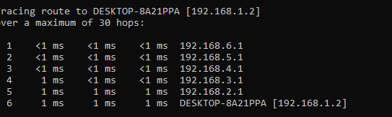

IPv6

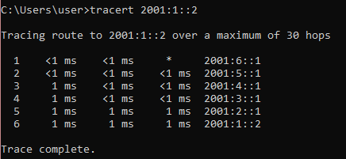

**Show Routes**

IPv4

IPv6

**Pings Between PCs**

**Problems**

We had to refresh our minds on basic cisco commands and configurations settings which took a minute. OSPF specifically, which is the focal point of this lab took a lot of trial and error to get working. A bigger problem we had while relearning OSPF for single area was forgetting to put all necessary networks in. An issue that took us some time to figure out was when we were not able to ping from pc across routers when routers could ping other routers, the issue was that Wi-Fi was on, so the PC was not using ethernet and going through the routers.

**Conclusion**

In conclusion we made addressing schemes for IPv4 and IPv6 Single Area OSPF for a 5-router network, while relearning the basics of configuration. We learned how to set up Single Area v2 and v3 OSPF.